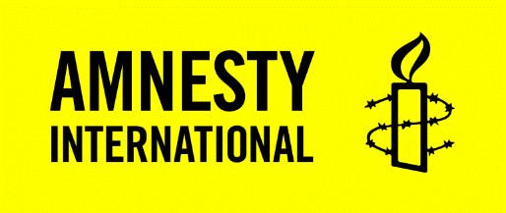
Stop Paving Over Our Rights – Comic book discussion guide
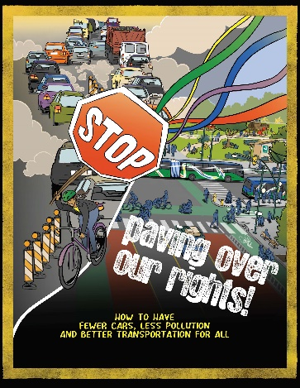
Thank you for ordering copies of our new comic book! By sharing and discussing Stop Paving Over Our Rights, you will help students and community members connect the dots between transportation, climate change, and human rights.
The story follows Andy and Samira as they organize against a highway expansion project in their neighbourhood. This action helps spark a positive transformation and results in a healthier community with cleaner air, more affordable and accessible transportation, and less carbon footprint.
And we all want that for ourselves and the generations to come!
Climate change is a human rights crisis
Amnesty International has published numerous reports on the climate emergency as a human rights crisis. One recent report warns that climate change threatens the civil, political, economic, social and cultural rights of present and future generations and, ultimately, the future of humanity. The report calls on governments to stop spending public funds on urban highway expansion, and instead promote the development of low-carbon transport infrastructure.
Amnesty also calls for governments to implement policies that reduce our reliance on car travel and the number of cars on the road. Solutions could include redesigning city space to make provisions for walking and cycling, and providing affordable, accessible, and convenient public transport.
Transportation and greenhouse gas pollution
Transportation is the second largest source of greenhouse gas (GHG) pollution in Canada. Emissions have been climbing relentlessly. Globally, GHG pollution from transport has more than doubled since 1970 and is increasing at a faster rate than any other energy end-use sector. Highway expansion is a serious threat to the futures of young people. There are about 1.3 billion cars in operation globally.
The manufacturing of automobiles of all types, including electric vehicles, is still mainly powered with climate-disrupting fossil fuels.
Concrete and steel used to build parking structures and urban highways also have a massive greenhouse gas footprint. If we keep increasing the number of vehicles in Canada and globally, the climate impact would be catastrophic.
The impact of mining minerals for electric car batteries is explored in the first comic in this series (available through the webpage below).

Let’s get the conversation started!
Stop Paving Over Our Rights will help launch important conversations around the kitchen table, in the classroom, and in the community. Ideally, each participant will have a copy and be able to access the campaign webpage. However, the comic is only 12 pages and could be shared by multiple readers.
Often, the richest conversations happen in small groups and this is a good place to start if you are in a classroom or community setting. Invite the groups to go through some or all the questions, with one or more participants from each group reporting back to the full group.
Charting report-back highlights on a flip chart or whiteboard helps everyone see and reflect on what others have said, and perhaps generate further discussions. These sample discussion questions are just a starting point – you are welcome to take the ones that work best for your learners and add your own!
Sample discussion questions
- Samira and Andy joined a community protest about a highway expansion project. Have you ever expressed concern about a similar project that was going to take away school or parkland in your neighbourhood? What did you or others do about? How did it turn out? What did you learn?
- Do you agree that having more electric buses and dedicating more lanes to public transportation is the right thing for governments to do? Studies show that when road space is reallocated to public transit lanes, protected bicycle lanes, and space for walking, traffic ‘evaporates’ and traffic speeds usually stay about the same. What do you think?
- The comic includes illustrations of people with disabilities getting around with and without cars. This includes a paratransit vehicle travelling on a bus lane, and a person on a mobility scooter on a protected bike and roll lane. How else can communities support better transportation for all?
- What other ways can you think of to reduce the number of cars on the road?
Additional resources
This blog post describes how this comic fits into our Climate Justice campaign and offers further actions you can take: https://www.amnesty.ca/climate-justice/stop-paving-over-our-rights-comic-book-ready-for-distribution/
This webpage offers more resources and actions linked to Amnesty’s ongoing Climate Justice and Corporate Accountability campaign: https://www.amnesty.ca/what-we-do/recharge-for-rights/

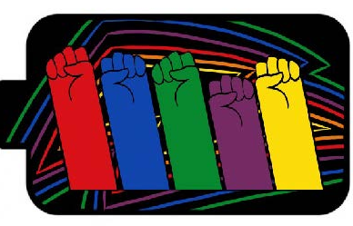
Together we will power a just future!
September 2023

